The Art Gallery Sales Tracking System

A system for 100 artists, 1000 pieces, 5000 customers per year Phase 2

Gabelli School of Business

Fordham University

ATOM

Yifan Ren

Xin Sui

Jian Shen

Chang Liu

**Entity Relationship Diagram for The Art Gallery Sales Tracking System**

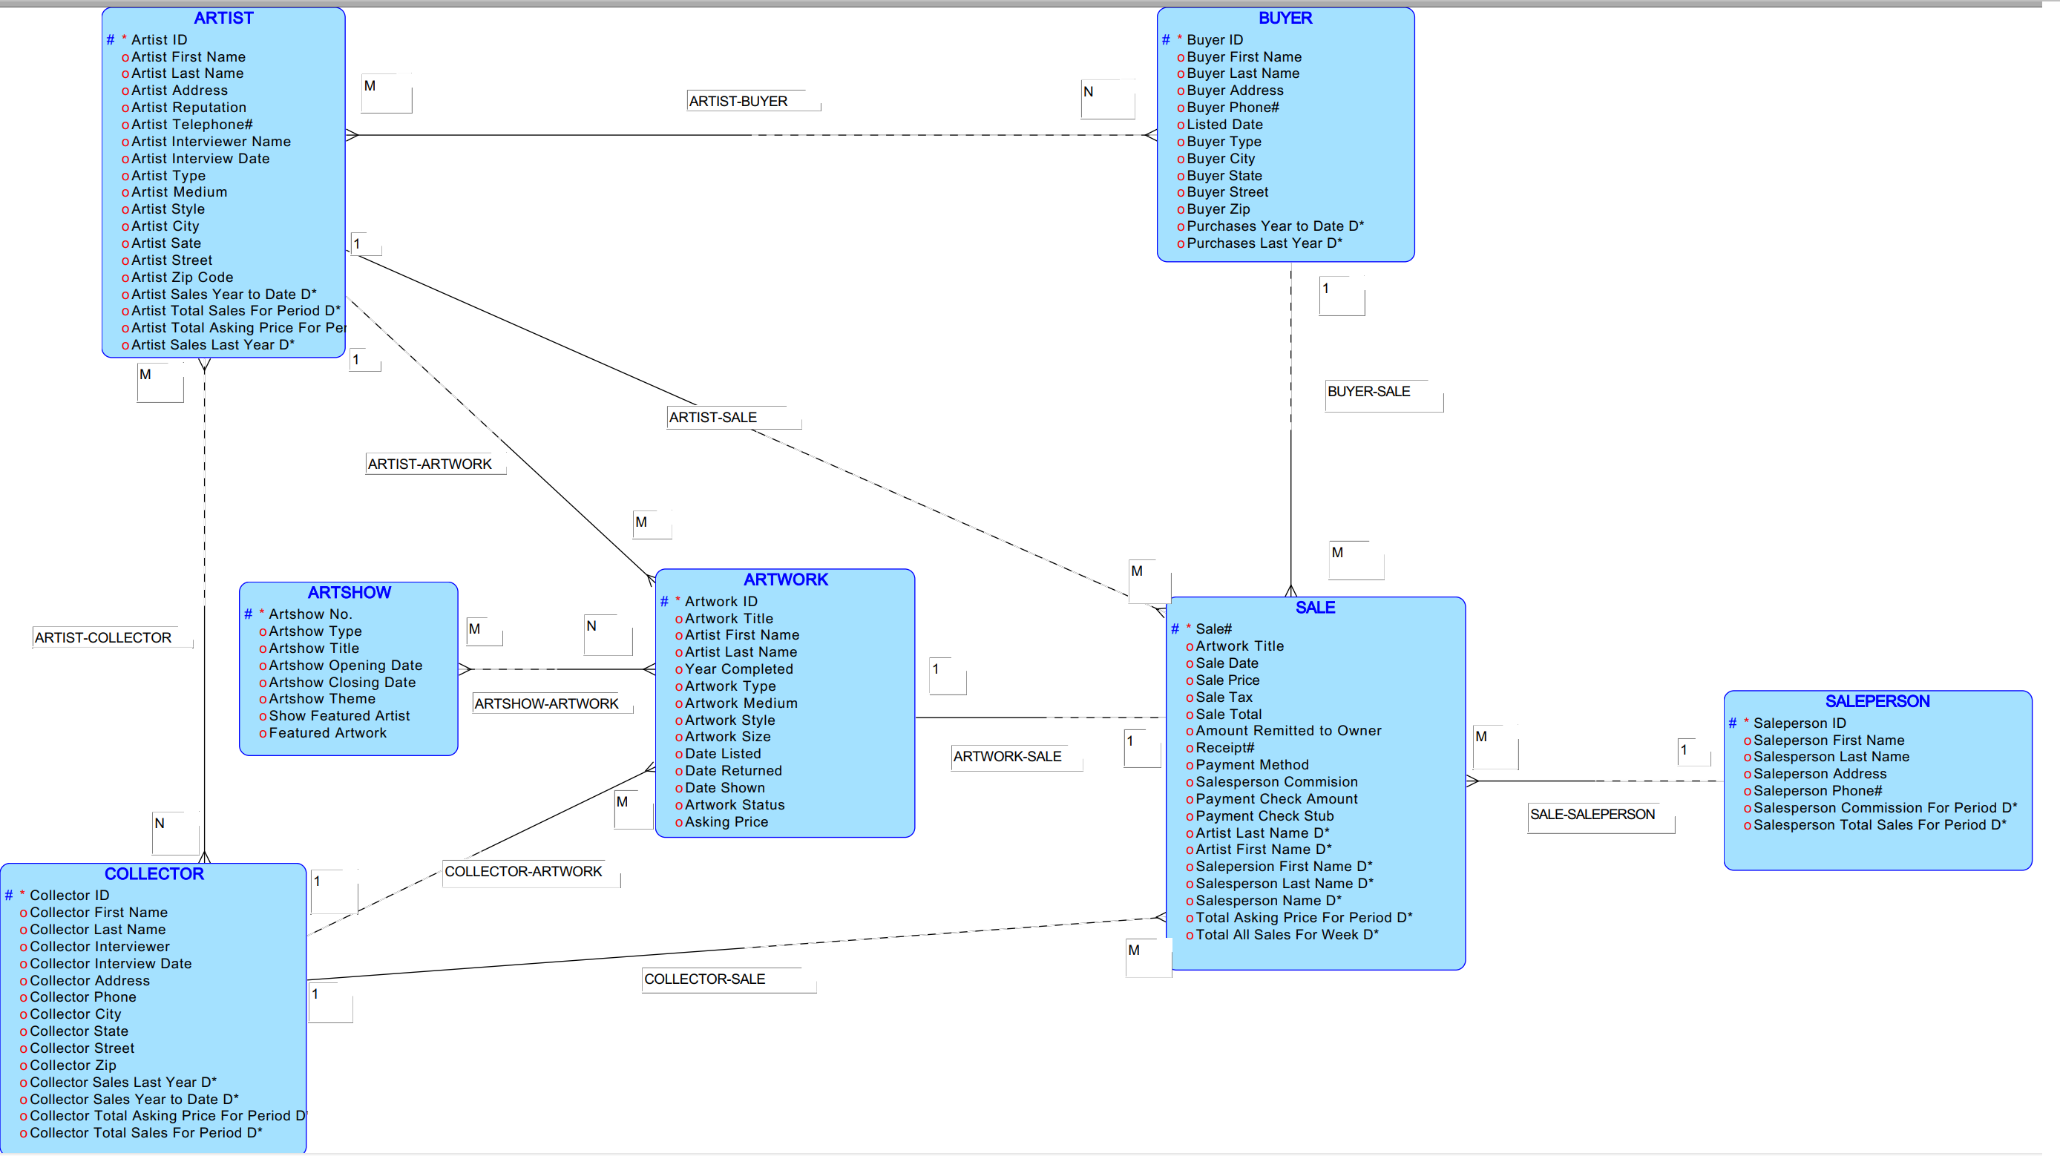

**Data Dictionary for Entity Relationship Model**

|  |  |  |  |
| --- | --- | --- | --- |
| Entity Name | Attribute | Unique Identifier | DataType |
| ARTSHOW | Artshow No. | √ | NUMERIC |
| Artshow Type |  | CHAR |
| Artshow Title |  | CHAR |
| Artshow Opening Date |  | Date |
| Artshow Closing Date |  | Date |
| Artshow Theme |  | CHAR |
| Show Featured Artist |  | CHAR |
| Featured Artwork |  | CHAR |
| ARTIST | Artist ID | √ | NUMERIC |
| Artist Last Name |  | CHAR |
| Artist First Name |  | CHAR |
| Artist Address |  | CHAR |
| Artist Reputation |  | CHAR |
| Artist Telephone# |  | Integer |
| Artist Interviewer Name |  | CHAR |
| Artist Interview Date |  | Date |
| ArtistType |  | CHAR |
| ArtistMedium |  | CHAR |
| ArtistStyle |  | CHAR |
| Artist Zip Code |  | Integer |
| Artist City |  | CHAR |
| Artist State |  | CHAR |
| Artist Street |  | CHAR |
| Artist Sales Year to Date D* |  | NUMERIC |
| Artist Total Sales For Period D* |  | NUMERIC |
| Artist Total Asking Price For Period D* |  | NUMERIC |
| Artist Sales Last Year D* |  | NUMERIC |
| ARTWORK | Artwork ID | √ | CHAR |
| Artwork Title |  | CHAR |
| Artist First Name |  | CHAR |
| Artist Last Name |  | Integer |
| Year Completed |  | CHAR |
| Artwork Type |  | CHAR |
| Artwork Style |  | CHAR |
| Artwork Size |  | Date |
| Date Listed |  | Date |
| Date Returned |  | Date |
| Date Shown |  | CHAR |
| Artwork Status |  | NUMERIC |
| Asking Price |  | NUMERIC |

**Data Dictionary for Entity Relationship Model**

|  |  |  |  |
| --- | --- | --- | --- |
| Entity Name | Attribute | Unique Identifier | DataType |
| COLLECTOR | Collector ID | √ | NUMERIC |
| Collector First Name |  | CHAR |
| Collector Last Name |  | CHAR |
| Collector Interviewer |  | CHAR |
| Collector Interview Date |  | Date |
| Collector Address |  | CHAR |
| Collector City |  | CHAR |
| Collector State |  | CHAR |
| Collector Street |  | CHAR |
| Collector Zip |  | Integer |
| Collector Phone |  | Integer |
| Collector Sales Last Year D* |  | NUMERIC |
| Collector Sales Year to Date D* |  | NUMERIC |
| Collector Total Sales For Period D* |  | NUMERIC |
| Collector Total Asking Price For Period D* |  | NUMERIC |
| SALE | Sale# | √ | NUMERIC |
| Artwork Title |  | CHAR |
| Sale Date |  | Date |
| Sale Price |  | NUMERIC |
| Sale Tax |  | NUMERIC |
| Sale Total |  | NUMERIC |
| Amount Remitted to Owner |  | NUMERIC |
| Receipt# |  | NUMERIC |
| Payment Method |  | CHAR |
| Salesperson Commission |  | NUMERIC |
| Payment Check Amount |  | NUMERIC |
| Payment Check Stub |  | NUMERIC |
| Artist Last Name D* |  | CHAR |
| Artist First Name D* |  | CHAR |
| Salesperson First Name D* |  | CHAR |
| Salesperson Last Name D* |  | CHAR |
| Salesperson Name |  | CHAR |
| Total Asking Price For Period D* |  | NUMERIC |
| Total All Sales For Week D* |  | NUMERIC |
| SALEPERSON | Saleperson ID | √ | NUMERIC |
| Saleperson First Name |  | CHAR |
| Saleperson Last Name |  | CHAR |
| Saleperson Address |  | CHAR |
| Saleperson Phone# |  | Integer |
| Salesperson Commission For Period D* |  | NUMERIC |
| Salesperson Total Sales For Period D* |  | NUMERIC |

**Data Dictionary for Entity Relationship Model**

|  |  |  |  |
| --- | --- | --- | --- |
| Entity Name | Attribute | Unique Identifier | DataType |
| BUYER | Buyer ID | √ | NUMERIC |
| Buyer First Name |  | CHAR |
| Buyer Address |  | CHAR |
| Buyer City |  | CHAR |
| Buyer Sate |  | CHAR |
| Buyer Street |  | CHAR |
| Buyer Last Name |  | CHAR |
| Buyer Phone# |  | Integer |
| Buyer Zip |  | Integer |
| Buyer Type |  | CHAR |
| Purchases Last Year D* |  | NUMERIC |
| Purchases Year to Date D* |  | NUMERIC |

**List of assumptions for Entity Relationship Model**

* Artist Sales Year to Date D*, Artist Total Sales For Period D*, Artist Sales Last Year D* are the descriptive attributes between ARTIST and SALE.
* Artist Total Asking Price For Period D**, is the descriptive attribute between ARTIST and ARTWORK.
* Collector Sales Last Year D*, Collector Sales Year to Date D*, Collector Total Sales For Period D*, are the descriptive attributes between COLLECTOR and SALE.
* Collector Total Asking Price For Period D**, is the descriptive attribute between COLLECTOR and ARTWORK.
* Artist Last Name D*, Artist First Name D*, are the descriptive attributes between SALE and ARTIST.
* Total Asking Price For Period D*, is the descriptive attribute between SALE and ARTWORK.
* Salesperson First Name D*, Salesperson Last Name D*, Total All Sales For Week D* are the descriptive attributes between SALE and SALEPERSON.
* Salesperson Commission For Period D*, Salesperson Total Sales For Period D* are the descriptive attributes between SALEPERSON and SALE.
* Purchases Last Year D*, Purchases Year to Date D* are the descriptive attributes between BUYER and SALE.

**Default Relational Model for The Art Gallery Sales Tracking System**

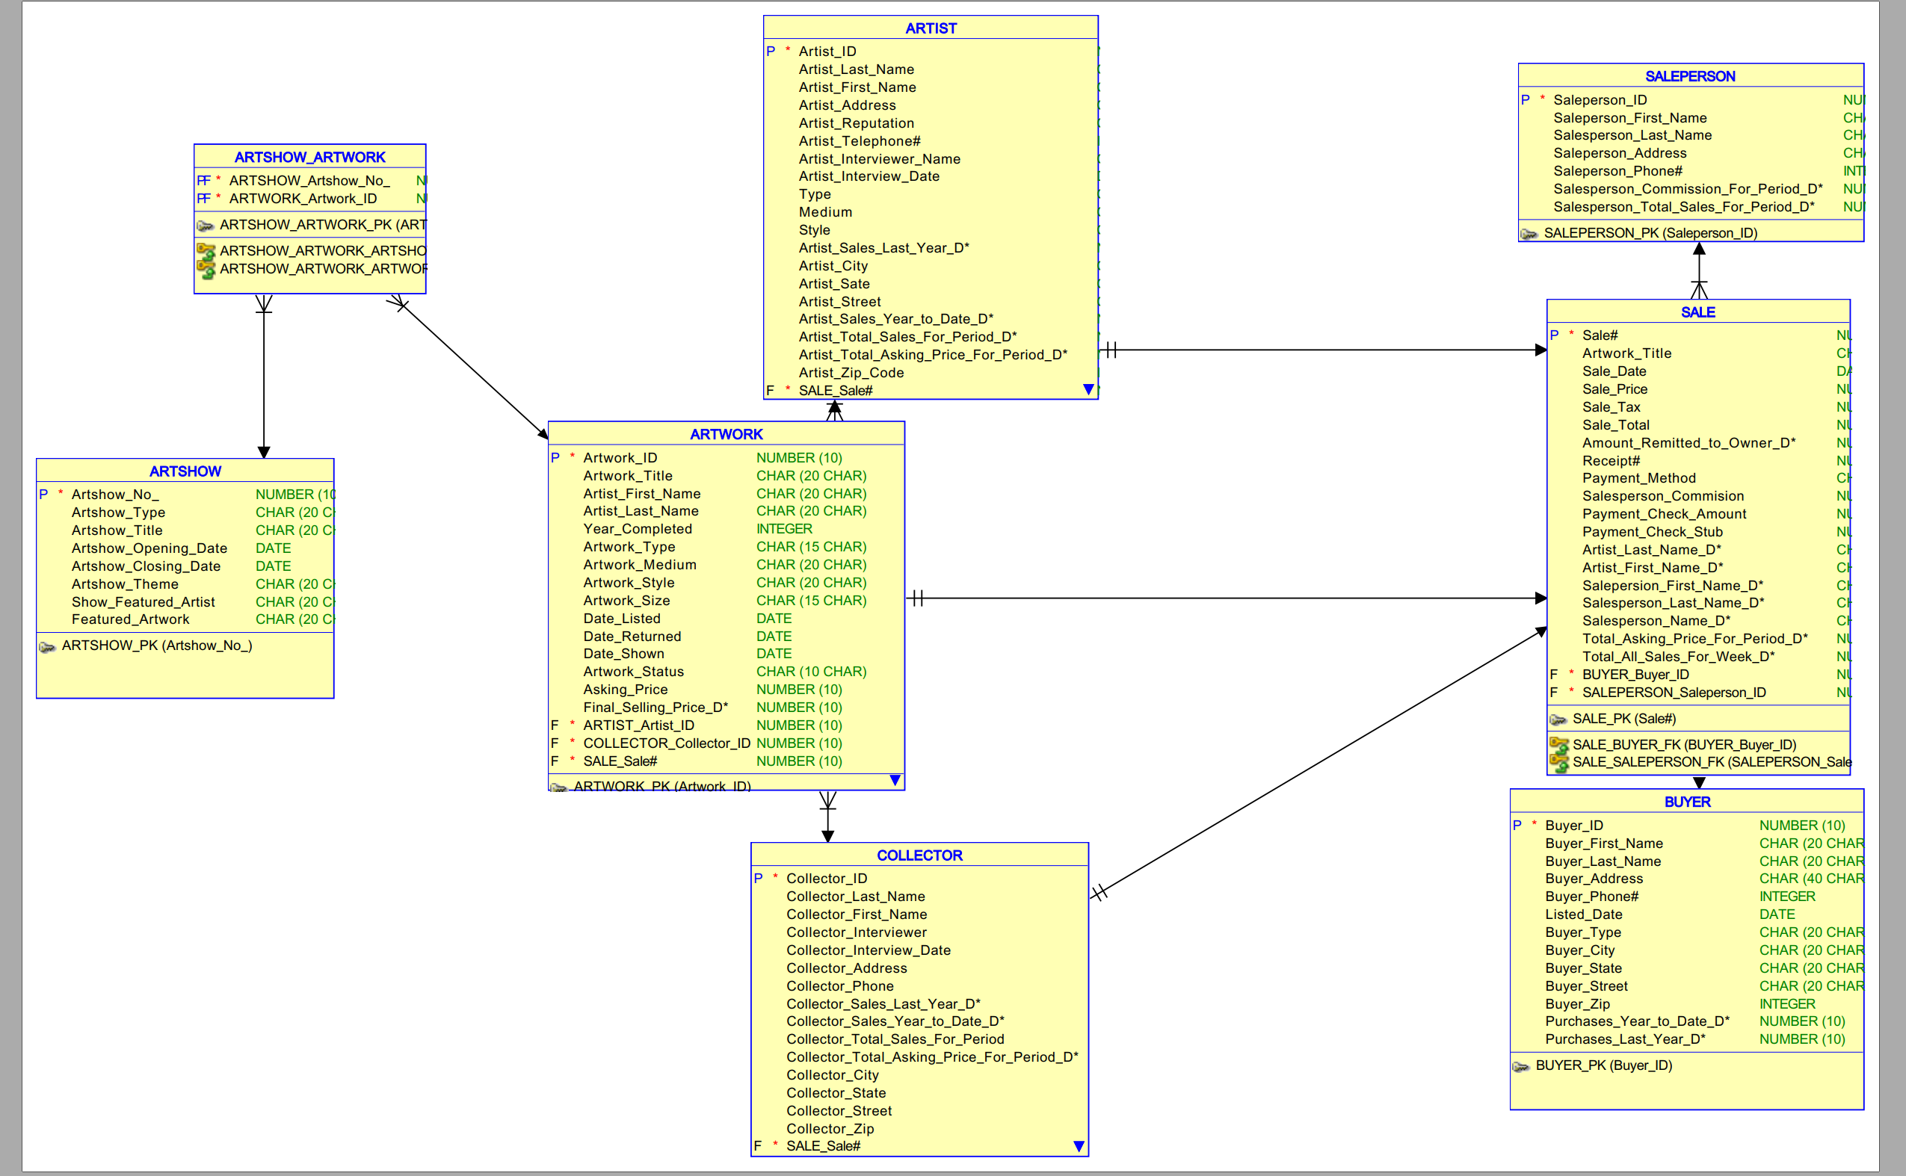

**Revised Relational Model for The Art Gallery Sales Tracking System**

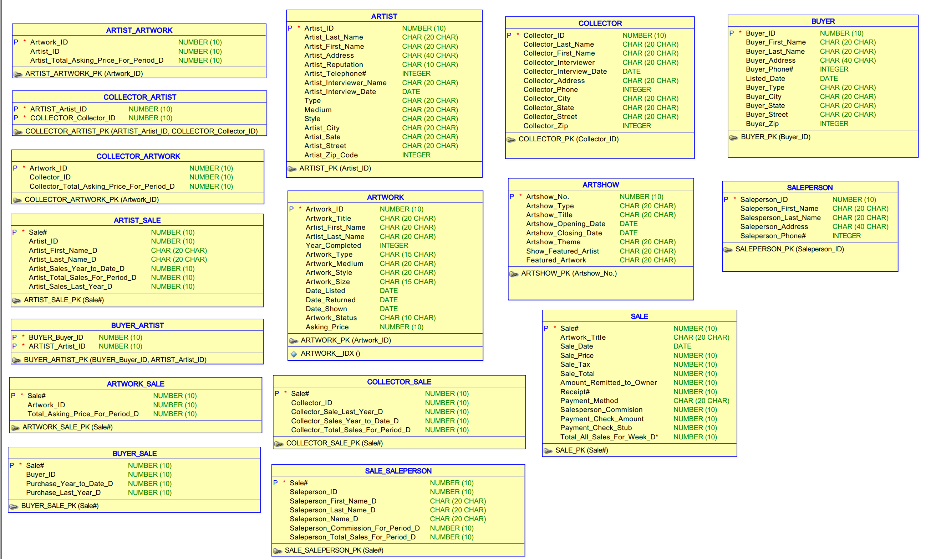

**Normalized Relational Model for The Art Gallery Sales Tracking System**

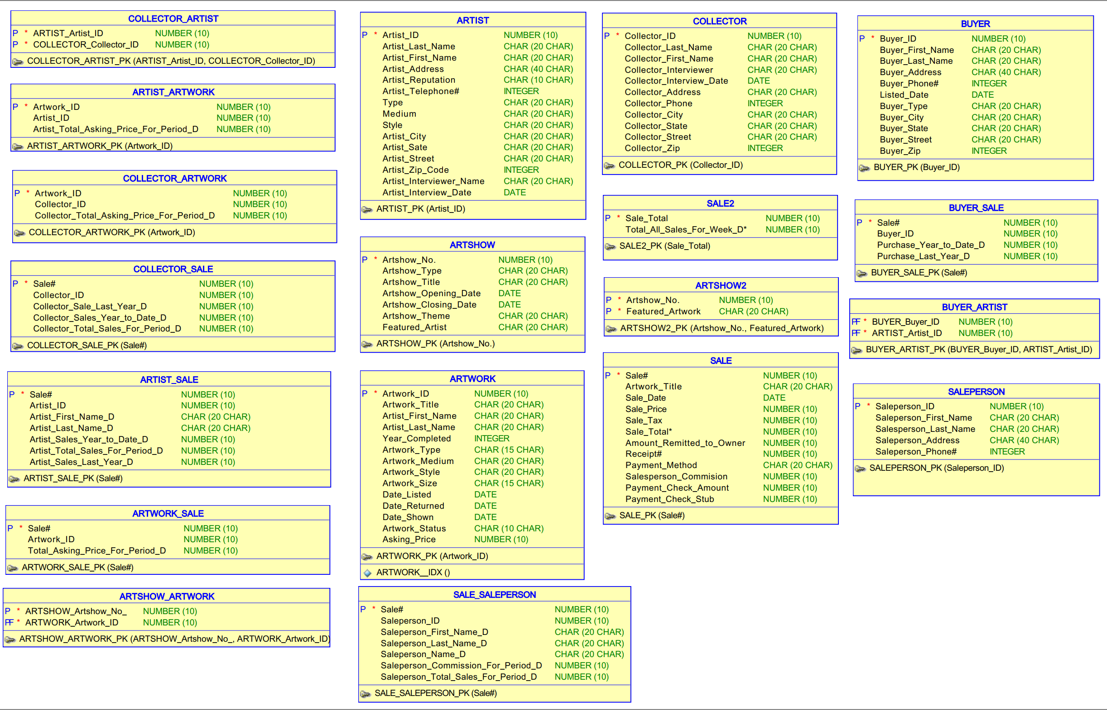

**Data Dictionary for Normalized Relational Model**

|  |  |  |  |
| --- | --- | --- | --- |
| Entity Name | Attribute | Primary & Foreign Keys | DataType |
| COLLECTOR_ARTIST | ARTIST_Artist_ID | Primary Key | NUMERIC |
| COLLECTOR_Collector_ID | Primary Key | NUMERIC |
| ARTIST_ARTWORK | Artwork_ID | Primary Key | NUMERIC |
| Artist_ID |  | NUMERIC |
| Artist_Total_Asking_Price_For_Period_D* |  | NUMERIC |
| COLLECTOR_ARTWORK | Artwork_ID | Primary Key | NUMERIC |
| Collector_ID |  | NUMERIC |
| Collector_Total_Asking_Price_For_Period_D* |  | NUMERIC |
| COLLECTOR_SALE | Sale# | Primary Key | NUMERIC |
| Collector_ID |  | NUMERIC |
| Collector_Sale_Last_Year_D* |  | NUMERIC |
| Collector_Sales_Year_to_Date_D* |  | NUMERIC |
| Collector_Total_Sales_For_Period_D* |  | NUMERIC |
| ARTIST_SALE | Sale# | Primary Key | NUMERIC |
| Artist_ID |  | NUMERIC |
| Artist_First_Name_D* |  | CHAR |
| Artist_Last_Name_D* |  | CHAR |
| Artist_Sales_Year_to_Date_D* |  | NUMERIC |
| Artist_Total_Sales_For_Period_D* |  | NUMERIC |
| Artist_Sales_Last_Year_D* |  | NUMERIC |
| ARTWORK_SALE | Sale# | Primary Key | NUMERIC |
| Artwork_ID |  | NUMERIC |
| Total_Asking_Price_For_Period_D* |  | NUMERIC |
| ARTSHOW_ARTWORK | ARTSHOW_Artshow_No | Primary Key | NUMERIC |
| ARTWORK_Artwork_ID | Primary Key | NUMERIC |
| SALE_SALEPERSON | Sale# | Primary Key | NUMERIC |
| Saleperson_ID |  | NUMERIC |
| Saleperson_First_Name_D* |  | CHAR |
| Saleperson_Last_Name_D* |  | CHAR |
| Saleperson_Name_D* |  | CHAR |
| Saleperson_Commission_For_Period_D* |  | NUMERIC |
| Saleperson_Total_Sales_For_Period_D* |  | NUMERIC |
| BUYER_ARTIST | BUYER_Buyer_ID | Primary Key | NUMERIC |
| ARTIST_Artist_ID | Primary Key | NUMERIC |

**Data Dictionary for Normalized Relational Model**

|  |  |  |  |
| --- | --- | --- | --- |
| Entity Name | Attribute | Primary & Foreign Keys | DataType |
| BUYER_SALE | Sale# | Primary Key | NUMERIC |
| Buyer_ID |  | NUMERIC |
| Purchase_Year_to_Date_D* |  | NUMERIC |
| Purchase_Last_Year_D* |  | NUMERIC |
| ARTIST | Artist_ID | Primary Key | NUMERIC |
| Artist_Last_Name |  | CHAR |
| Artist_First_Name |  | CHAR |
| Artist_Address |  | CHAR |
| Artist_Reputation |  | CHAR |
| Artist_Telephone# |  | Integer |
| Type |  | CHAR |
| Medium |  | CHAR |
| Style |  | CHAR |
| Artist_City |  | CHAR |
| Artist_Sate |  | CHAR |
| Artist_Street |  | CHAR |
| Artist_Zip_Code |  | Integer |
| Artist_Interviewer_Name |  | CHAR |
| Artist_Interview_Date |  | Date |
| ARTSHOW | Artshow_No. | Primary Key | NUMERIC |
| Artshow_Type |  | CHAR |
| Artshow_Title |  | CHAR |
| Artshow_Opening_Date |  | Date |
| Artshow_Closing_Date |  | Date |
| Artshow_Theme |  | CHAR |
| Featured_Artist |  | CHAR |
| ARTSHOW2 | Artshow_No. | Primary Key | NUMERIC |
| Featured_Artwork |  | CHAR |
| ARTWORK | Artwork_ID | Primary Key | NUMERIC |
| Artwork_Title |  | CHAR |
| Artist_First_Name |  | CHAR |
| Artist_Last_Name |  | CHAR |
| Year_Completed |  | Integer |
| Artwork_Type |  | CHAR |
| Artwork_Medium |  | CHAR |
| Artwork_Style |  | CHAR |
| Artwork_Size |  | CHAR |
| Date_Listed |  | Date |
| Date_Returned |  | Date |
| Date_Shown |  | Date |
| Artwork_Status |  | CHAR |
| Asking_Price |  | NUMERIC |

**Data Dictionary for Normalized Relational Model**

|  |  |  |  |
| --- | --- | --- | --- |
| Entity Name | Attribute | Primary & Foreign Keys | DataType |
| COLLECTOR | Collector_ID | Primary Key | NUMERIC |
| Collector_Last_Name |  | CHAR |
| Collector_First_Name |  | CHAR |
| Collector_Interviewer |  | CHAR |
| Collector_Interview_Date |  | Date |
| Collector_Address |  | CHAR |
| Collector_Phone |  | Integer |
| Collector_City |  | CHAR |
| Collector_State |  | CHAR |
| Collector_Street |  | CHAR |
| Collector_Zip |  | Integer |
| SALE | Sale# | Primary Key | NUMERIC |
| Artwork_Title |  | CHAR |
| Sale_Date |  | Date |
| Sale_Price |  | NUMERIC |
| Sale_Tax |  | NUMERIC |
| Sale_Total* |  | NUMERIC |
| Amount_Remitted_to_Owner |  | NUMERIC |
| Receipt# |  | NUMERIC |
| Payment_Method |  | CHAR |
| Salesperson_Commision |  | NUMERIC |
| Payment_Check_Amount |  | NUMERIC |
| Payment_Check_Stub |  | NUMERIC |
| SALE2 | Sale_Total | Primary Key | NUMERIC |
| Total_All_Sales_For_Week_D* |  | NUMERIC |
| BUYER | Buyer_ID | Primary Key | NUMERIC |
| Buyer_First_Name |  | CHAR |
| Buyer_Last_Name |  | CHAR |
| Buyer_Address |  | CHAR |
| Buyer_Phone# |  | Integer |
| Listed_Date |  | Date |
| Buyer_Type |  | CHAR |
| Buyer_City |  | CHAR |
| Buyer_State |  | CHAR |
| Buyer_Street |  | CHAR |
| Buyer_Zip |  | Integer |
| SALEPERSON | Saleperson_ID | Primary Key | NUMERIC |
| Saleperson_First_Name |  | CHAR |
| Salesperson_Last_Name |  | CHAR |
| Saleperson_Address |  | CHAR |
| Saleperson_Phone# |  | Integer |

**List of assumptions for Normalized Relational Model**

* Artist_Telephone#, Artist_Zip_Code, Style could have multiple values (repeating group) for a ARTIST
* Artist_Address, Artist_City, Artist_Sate, Artist_Street depend on Artist_Zip_Code
* An ARTIST could have have several Artist_Interviewer_Name, Artist_Interview_Date
* Collector_Telephone#, Collector_Zip_Code could have multiple values (repeating group) for a COLLECTOR
* Collector_Address, Collector_City, Collector_Sate, Collector_Street depend on Collector_Zip_Code
* An COLLECTOR could have have several Collector_Interviewer_Name, Collector_Interview_Date
* Buyer_Phone #, Buyer_Zip, could have multiple values (repeating group) for a BUYER
* Buyer_Address, Buyer_City, Buyer_Sate, Buyer_Street depend on Buyer_Zip
* Saleperson_Phone#, Saleperson_Address, could have multiple values (repeating group) for a SALEPERSON
* Featured_Artist could have multiple values (repeating group) for a ARTSHOW.
* Featured_Artwork depends on Artshow_No.
* Collector_Telephone#, Collector_Zip_Code, Style could have multiple values (repeating group) for an ARTWORK
* An ARTWORK could have have several Asking_Price
* Date_Shown, Date_Listed, Date_Returned depends on Artwork_Medium
* Sale_Total = Sale_Price + Sale_Tax
* Amount_Remitted_to_Owner = Sale_Total - Salesperson_Commision
* Total_All_Sales_For_Week_D* depend on Sale_Total
* Payment_Check_Stub, Payment_Check_Amount, Receipt# depend on Payment_Method
* Total_All_Sales_For_Week_D depend on Sale_Total
* Artist_Total_Asking_Price_For_Period_D* = Adding up the individual Asking_Price of Artist within Period
* Collector_Total_Asking_Price_For_Period_D* = Adding up the individual Asking_Price of Collector within Period
* Total_Asking_Price_For_Period_D* = Adding up the individual Asking_Price within Period
* Collector_Sale_Last_Year_D* = Adding up the Sale_Total* of Collector last year
* Collector_Total_Sales_For_Period_D* = Adding up the Sale_Total* of Collector in Period
* *Collector_Sales_Year_to_Date_D* = Adding up all the* Sale_Total* of Collector
* Artist_Total_Sales_For_Period_D* = Adding up the Sale_Total* of Artist in Period
* Artist_Sales_Last_Year_D* = Adding up the Sale_Total* of Artist last year
* Artist_Sales_Year_to_Date_D* = Adding up all the Sale_Total* of Artist
* Saleperson_Commission_For_Period_D* = Adding up the Salesperson’s Salesperson_Commission in Period
* Saleperson_Total_Sales_For_Period_D* = Adding up the Salesperson’s Sale_Total* in Period
* Purchase_Last_Year_D* = Adding up the Sale_Total* last year
* Purchase_Year_to_Date_D* = Adding up all the Sale_Total*

**Generate the DDL for The Art Gallery Sales Tracking System**

CREATE TABLE artist (

artist_id NUMBER(10) NOT NULL,

artist_last_name CHAR(20 CHAR),

artist_first_name CHAR(20 CHAR),

artist_address CHAR(40 CHAR),

artist_reputation CHAR(10 CHAR),

artist_telephone# INTEGER,

type CHAR(20 CHAR),

medium CHAR(20 CHAR),

style CHAR(20 CHAR),

artist_city CHAR(20 CHAR),

artist_sate CHAR(20 CHAR),

artist_street CHAR(20 CHAR),

artist_zip_code INTEGER,

artist_interviewer_name CHAR(20 CHAR),

artist_interview_date DATE

);

ALTER TABLE artist ADD CONSTRAINT artist_pk PRIMARY KEY ( artist_id );

CREATE TABLE artist_artwork (

artwork_id NUMBER(10) NOT NULL,

artist_id NUMBER(10) NOT NULL,

artist_total_asking_price_for_period_d NUMBER(10)

);

ALTER TABLE artist_artwork ADD CONSTRAINT artist_artwork_pk PRIMARY KEY ( artwork_id );

CREATE TABLE artist_sale (

sale# NUMBER(10) NOT NULL,

artist_id NUMBER(10) NOT NULL,

artist_first_name_d CHAR(20 CHAR),

artist_last_name_d CHAR(20 CHAR),

artist_sales_year_to_date_d NUMBER(10),

artist_total_sales_for_period_d NUMBER(10),

artist_sales_last_year_d NUMBER(10)

);

ALTER TABLE artist_sale ADD CONSTRAINT artist_sale_pk PRIMARY KEY ( sale# );

CREATE TABLE artshow (

"Artshow_No." NUMBER(10) NOT NULL,

artshow_type CHAR(20 CHAR),

artshow_title CHAR(20 CHAR),

artshow_opening_date DATE,

artshow_closing_date DATE,

artshow_theme CHAR(20 CHAR),

featured_artist CHAR(20 CHAR)

);

ALTER TABLE artshow ADD CONSTRAINT artshow_pk PRIMARY KEY ( "Artshow_No." );

CREATE TABLE artshow_artwork (

artshow_artshow_no_ NUMBER(10) NOT NULL,

artwork_artwork_id NUMBER(10) NOT NULL

);

ALTER TABLE artshow_artwork ADD CONSTRAINT artshow_artwork_pk PRIMARY KEY ( artshow_artshow_no_,

artwork_artwork_id );

CREATE TABLE artshow2 (

"Artshow_No." NUMBER(10) NOT NULL,

featured_artwork CHAR(20 CHAR) NOT NULL

);

ALTER TABLE artshow2 ADD CONSTRAINT artshow2_pk PRIMARY KEY ( "Artshow_No.",

featured_artwork );

CREATE TABLE artwork (

artwork_id NUMBER(10) NOT NULL,

artwork_title CHAR(20 CHAR),

artist_first_name CHAR(20 CHAR),

artist_last_name CHAR(20 CHAR),

year_completed INTEGER,

artwork_type CHAR(15 CHAR),

artwork_medium CHAR(20 CHAR),

artwork_style CHAR(20 CHAR),

artwork_size CHAR(15 CHAR),

date_listed DATE,

date_returned DATE,

date_shown DATE,

artwork_status CHAR(10 CHAR),

asking_price NUMBER(10),

collector_id NUMBER(10) NOT NULL

);

ALTER TABLE artwork ADD CONSTRAINT artwork_pk PRIMARY KEY ( artwork_id );

CREATE TABLE artwork_sale (

sale# NUMBER(10) NOT NULL,

artwork_id NUMBER(10) NOT NULL,

total_asking_price_for_period_d NUMBER(10)

);

ALTER TABLE artwork_sale ADD CONSTRAINT artwork_sale_pk PRIMARY KEY ( sale# );

CREATE TABLE buyer (

buyer_id NUMBER(10) NOT NULL,

buyer_first_name CHAR(20 CHAR),

buyer_last_name CHAR(20 CHAR),

buyer_address CHAR(40 CHAR),

buyer_phone# INTEGER,

listed_date DATE,

buyer_type CHAR(20 CHAR),

buyer_city CHAR(20 CHAR),

buyer_state CHAR(20 CHAR),

buyer_street CHAR(20 CHAR),

buyer_zip INTEGER

);

ALTER TABLE buyer ADD CONSTRAINT buyer_pk PRIMARY KEY ( buyer_id );

CREATE TABLE buyer_artist (

buyer_buyer_id NUMBER(10) NOT NULL,

artist_artist_id NUMBER(10) NOT NULL

);

ALTER TABLE buyer_artist ADD CONSTRAINT buyer_artist_pk PRIMARY KEY ( buyer_buyer_id,

artist_artist_id );

CREATE TABLE buyer_sale (

sale# NUMBER(10) NOT NULL,

buyer_id NUMBER(10) NOT NULL,

purchase_year_to_date_d NUMBER(10),

purchase_last_year_d NUMBER(10)

);

ALTER TABLE buyer_sale ADD CONSTRAINT buyer_sale_pk PRIMARY KEY ( sale# );

CREATE TABLE collector (

collector_id NUMBER(10) NOT NULL,

collector_last_name CHAR(20 CHAR),

collector_first_name CHAR(20 CHAR),

collector_interviewer CHAR(20 CHAR),

collector_interview_date DATE,

collector_address CHAR(20 CHAR),

collector_phone INTEGER,

collector_city CHAR(20 CHAR),

collector_state CHAR(20 CHAR),

collector_street CHAR(20 CHAR),

collector_zip INTEGER

);

ALTER TABLE collector ADD CONSTRAINT collector_pk PRIMARY KEY ( collector_id );

CREATE TABLE collector_artist (

artist_artist_id NUMBER(10) NOT NULL,

collector_collector_id NUMBER(10) NOT NULL

);

ALTER TABLE collector_artist ADD CONSTRAINT collector_artist_pk PRIMARY KEY ( artist_artist_id,

collector_collector_id );

CREATE TABLE collector_artwork (

artwork_id NUMBER(10) NOT NULL,

collector_id NUMBER(10),

collector_total_asking_price_for_period_d NUMBER(10)

);

ALTER TABLE collector_artwork ADD CONSTRAINT collector_artwork_pk PRIMARY KEY ( artwork_id );

CREATE TABLE collector_sale (

sale# NUMBER(10) NOT NULL,

collector_id NUMBER(10) NOT NULL,

collector_sale_last_year_d NUMBER(10),

collector_sales_year_to_date_d NUMBER(10),

collector_total_sales_for_period_d NUMBER(10)

);

ALTER TABLE collector_sale ADD CONSTRAINT collector_sale_pk PRIMARY KEY ( sale# );

CREATE TABLE sale (

sale# NUMBER(10) NOT NULL,

artwork_title CHAR(20 CHAR),

sale_date DATE,

sale_price NUMBER(10),

sale_tax NUMBER(10),

"Sale_Total*" NUMBER(10),

amount_remitted_to_owner NUMBER(10),

receipt# NUMBER(10),

payment_method CHAR(20 CHAR),

salesperson_commision NUMBER(10),

payment_check_amount NUMBER(10),

payment_check_stub NUMBER(10)

);

ALTER TABLE sale ADD CONSTRAINT sale_pk PRIMARY KEY ( sale# );

CREATE TABLE sale_saleperson (

sale# NUMBER(10) NOT NULL,

saleperson_id NUMBER(10) NOT NULL,

saleperson_first_name_d CHAR(20 CHAR),

saleperson_last_name_d CHAR(20 CHAR),

saleperson_name_d CHAR(20 CHAR),

saleperson_commission_for_period_d NUMBER(10),

saleperson_total_sales_for_period_d NUMBER(10)

);

ALTER TABLE sale_saleperson ADD CONSTRAINT sale_saleperson_pk PRIMARY KEY ( sale# );

CREATE TABLE sale2 (

sale_total NUMBER(10) NOT NULL,

"Total_All_Sales_For_Week_D*" NUMBER(10)

);

ALTER TABLE sale2 ADD CONSTRAINT sale2_pk PRIMARY KEY ( sale_total );

CREATE TABLE saleperson (

saleperson_id NUMBER(10) NOT NULL,

saleperson_first_name CHAR(20 CHAR),

salesperson_last_name CHAR(20 CHAR),

saleperson_address CHAR(40 CHAR),

saleperson_phone# INTEGER

);

ALTER TABLE saleperson ADD CONSTRAINT saleperson_pk PRIMARY KEY ( saleperson_id );

ALTER TABLE artist_artwork

ADD CONSTRAINT artist_artwork_artist_fk FOREIGN KEY ( artist_id )

REFERENCES artist ( artist_id );

ALTER TABLE artist_artwork

ADD CONSTRAINT artist_artwork_artwork_fk FOREIGN KEY ( artwork_id )

REFERENCES artwork ( artwork_id );

ALTER TABLE artist_sale

ADD CONSTRAINT artist_sale_artist_fk FOREIGN KEY ( artist_id )

REFERENCES artist ( artist_id );

ALTER TABLE artist_sale

ADD CONSTRAINT artist_sale_sale_fk FOREIGN KEY ( sale# )

REFERENCES sale ( sale# );

ALTER TABLE artshow_artwork

ADD CONSTRAINT artshow_artwork_artshow_fk FOREIGN KEY ( artshow_artshow_no_ )

REFERENCES artshow ( "Artshow_No." );

ALTER TABLE artshow_artwork

ADD CONSTRAINT artshow_artwork_artwork_fk FOREIGN KEY ( artwork_artwork_id )

REFERENCES artwork ( artwork_id );

ALTER TABLE artshow2

ADD CONSTRAINT artshow2_artshow_fk FOREIGN KEY ( "Artshow_No." )

REFERENCES artshow ( "Artshow_No." );

ALTER TABLE artwork

ADD CONSTRAINT artwork_collector_fk FOREIGN KEY ( collector_id )

REFERENCES collector ( collector_id );

ALTER TABLE artwork_sale

ADD CONSTRAINT artwork_sale_artwork_fk FOREIGN KEY ( artwork_id )

REFERENCES artwork ( artwork_id );

ALTER TABLE artwork_sale

ADD CONSTRAINT artwork_sale_sale_fk FOREIGN KEY ( sale# )

REFERENCES sale ( sale# );

ALTER TABLE buyer_artist

ADD CONSTRAINT buyer_artist_artist_fk FOREIGN KEY ( artist_artist_id )

REFERENCES artist ( artist_id );

ALTER TABLE buyer_artist

ADD CONSTRAINT buyer_artist_buyer_fk FOREIGN KEY ( buyer_buyer_id )

REFERENCES buyer ( buyer_id );

ALTER TABLE buyer_sale

ADD CONSTRAINT buyer_sale_buyer_fk FOREIGN KEY ( buyer_id )

REFERENCES buyer ( buyer_id );

ALTER TABLE buyer_sale

ADD CONSTRAINT buyer_sale_sale_fk FOREIGN KEY ( sale# )

REFERENCES sale ( sale# );

ALTER TABLE collector_artist

ADD CONSTRAINT collector_artist_artist_fk FOREIGN KEY ( artist_artist_id )

REFERENCES artist ( artist_id );

ALTER TABLE collector_artist

ADD CONSTRAINT collector_artist_collector_fk FOREIGN KEY ( collector_collector_id )

REFERENCES collector ( collector_id );

ALTER TABLE collector_sale

ADD CONSTRAINT collector_sale_collector_fk FOREIGN KEY ( collector_id )

REFERENCES collector ( collector_id );

ALTER TABLE collector_sale

ADD CONSTRAINT collector_sale_sale_fk FOREIGN KEY ( sale# )

REFERENCES sale ( sale# );

ALTER TABLE sale_saleperson

ADD CONSTRAINT sale_saleperson_sale_fk FOREIGN KEY ( sale# )

REFERENCES sale ( sale# );

ALTER TABLE sale_saleperson

ADD CONSTRAINT sale_saleperson_saleperson_fk FOREIGN KEY ( saleperson_id )

REFERENCES saleperson ( saleperson_id );

-- Oracle SQL Developer Data Modeler Summary Report:

--

-- CREATE TABLE 19

-- CREATE INDEX 0

-- ALTER TABLE 39

-- CREATE VIEW 0

-- ALTER VIEW 0

-- CREATE PACKAGE 0

-- CREATE PACKAGE BODY 0

-- CREATE PROCEDURE 0

-- CREATE FUNCTION 0

-- CREATE TRIGGER 0

-- ALTER TRIGGER 0

-- CREATE COLLECTION TYPE 0

-- CREATE STRUCTURED TYPE 0

-- CREATE STRUCTURED TYPE BODY 0

-- CREATE CLUSTER 0

-- CREATE CONTEXT 0

-- CREATE DATABASE 0

-- CREATE DIMENSION 0

-- CREATE DIRECTORY 0

-- CREATE DISK GROUP 0

-- CREATE ROLE 0

-- CREATE ROLLBACK SEGMENT 0

-- CREATE SEQUENCE 0

-- CREATE MATERIALIZED VIEW 0

-- CREATE MATERIALIZED VIEW LOG 0

-- CREATE SYNONYM 0

-- CREATE TABLESPACE 0

-- CREATE USER 0

--

-- DROP TABLESPACE 0

-- DROP DATABASE 0

--

-- REDACTION POLICY 0

--

-- ORDS DROP SCHEMA 0

-- ORDS ENABLE SCHEMA 0

-- ORDS ENABLE OBJECT 0

--

-- ERRORS 0

-- WARNINGS 0

**Table *structures* for all tables arranged properly**

ARTIST

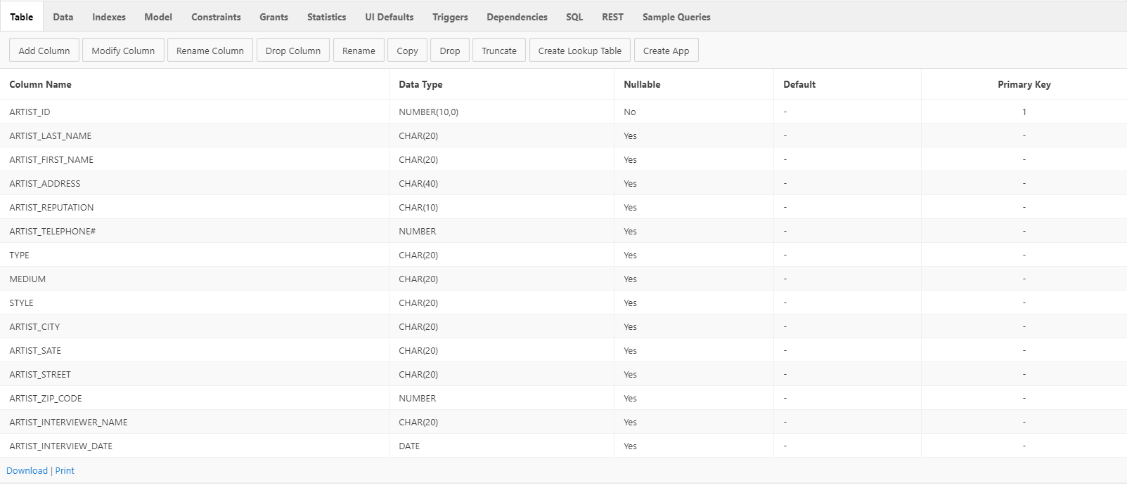

ARTIST_ARTWORK

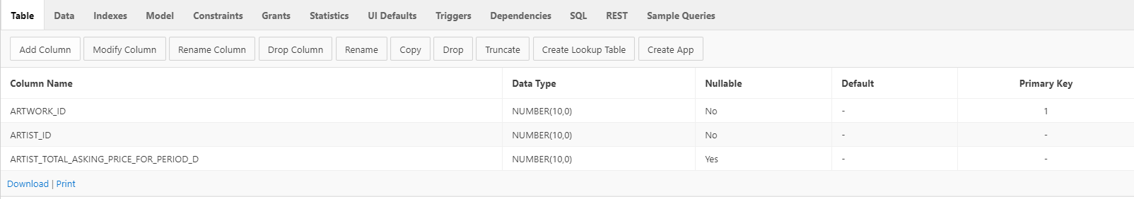

ARTIST_SALE

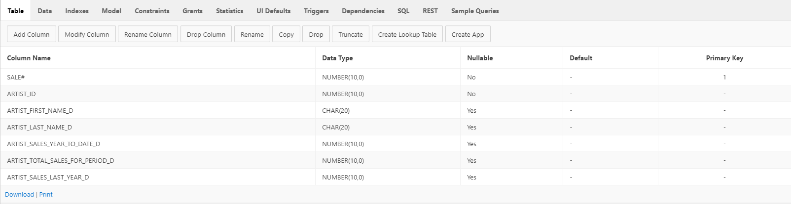

ARTSHOW

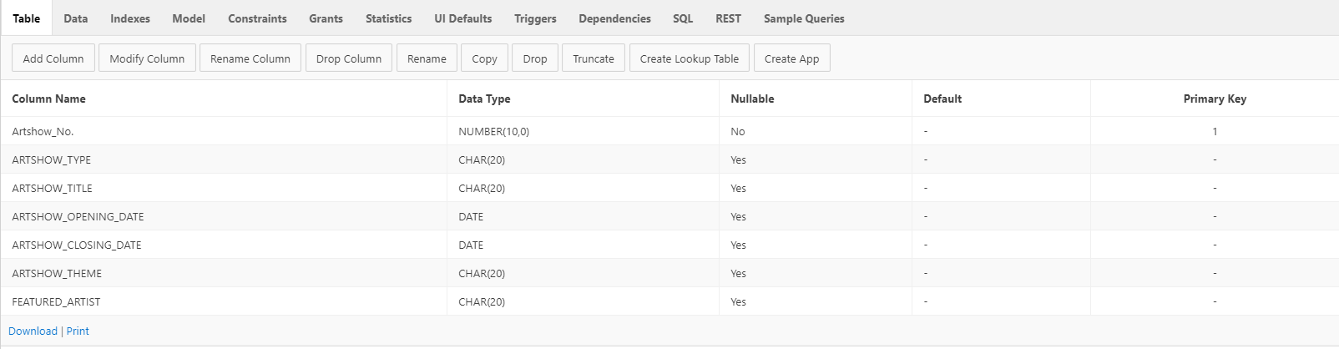

ARTSHOW2

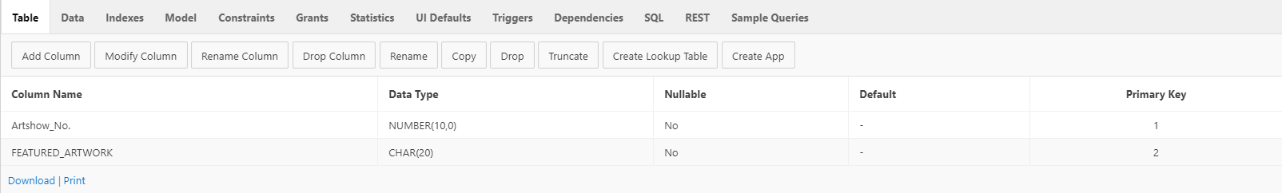

ARTSHOW_ARTWORK

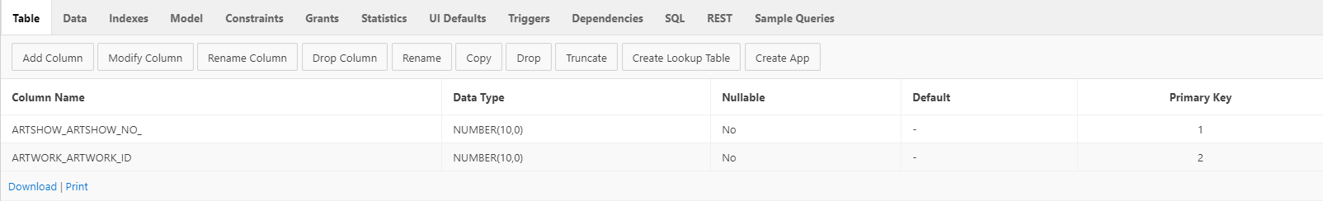

ARTWORK

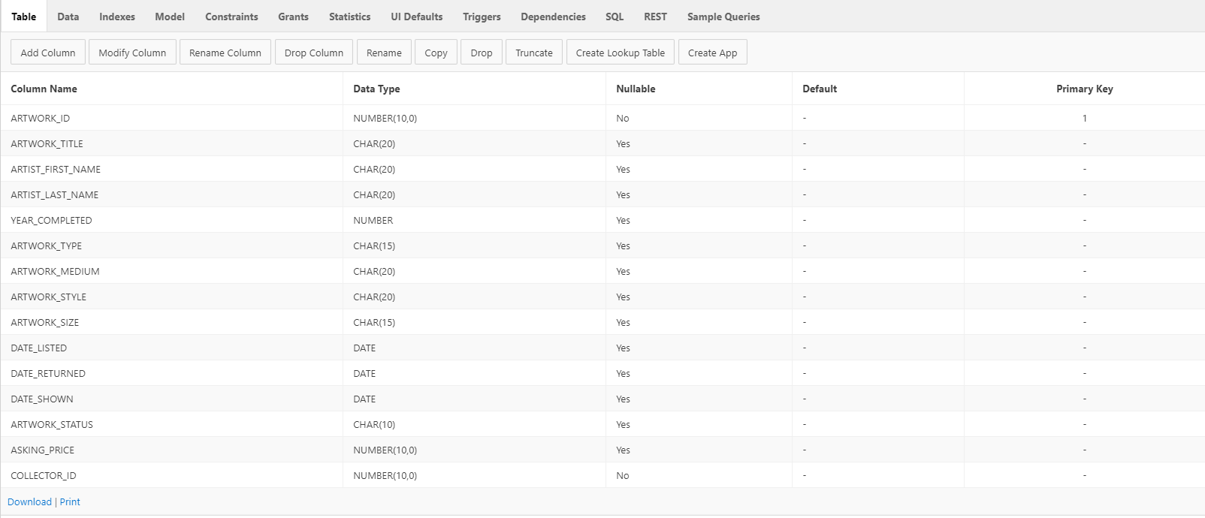

ARTWORK_SALE

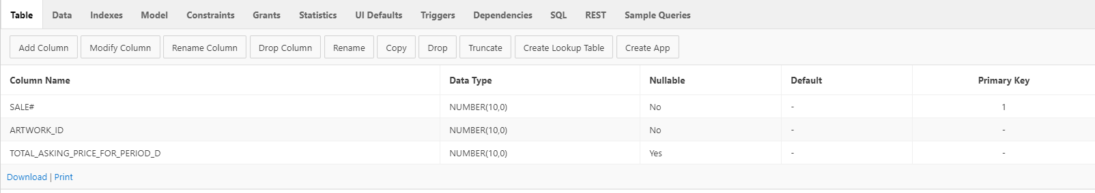

BUYER

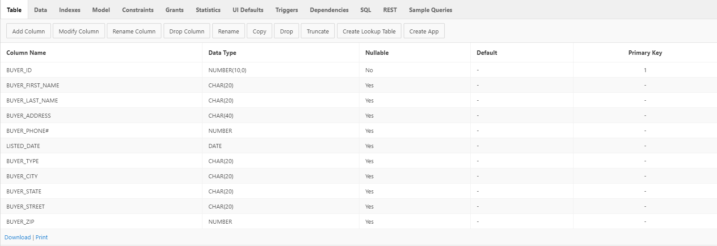

BUYER_ARTIST

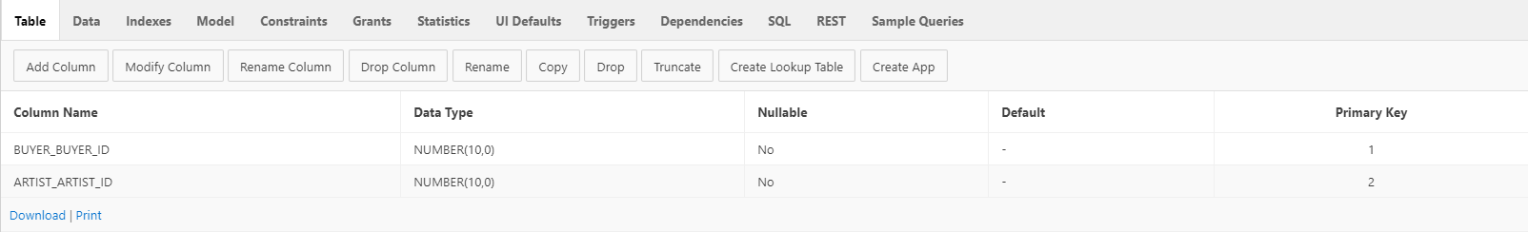

BUYER_SALE

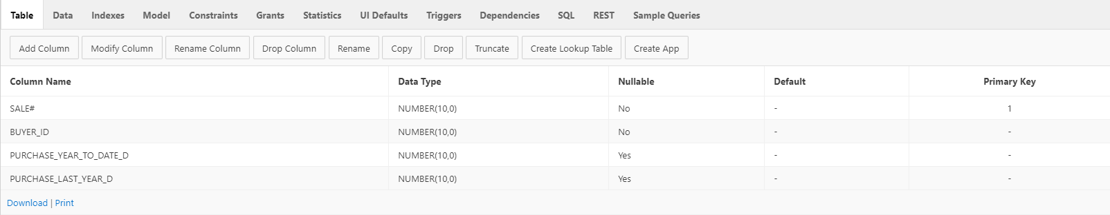

COLLECTOR

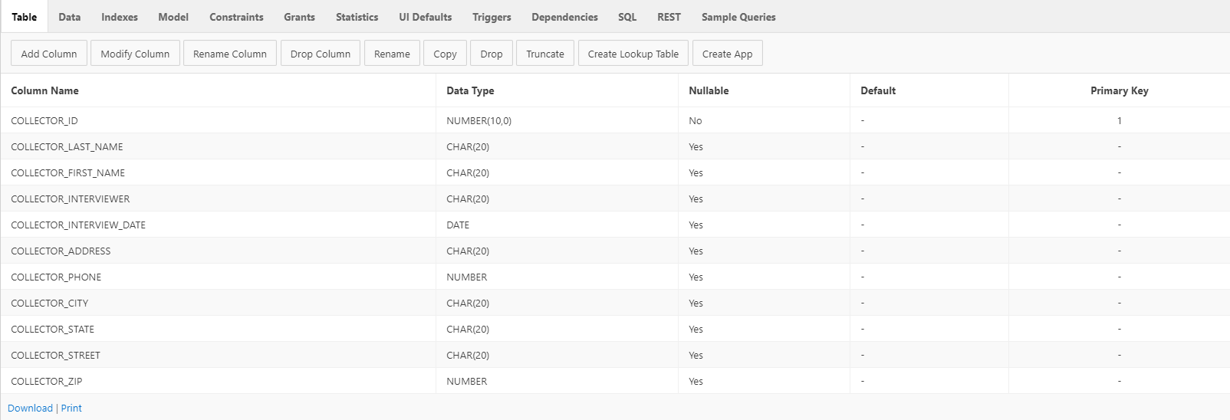

COLLECTOR_ARTIST

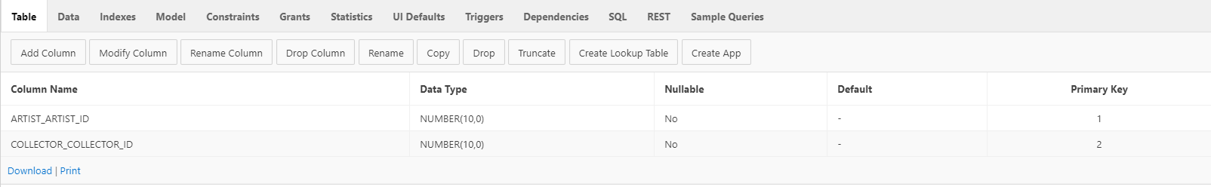

COLLECTOR_ARTWORK

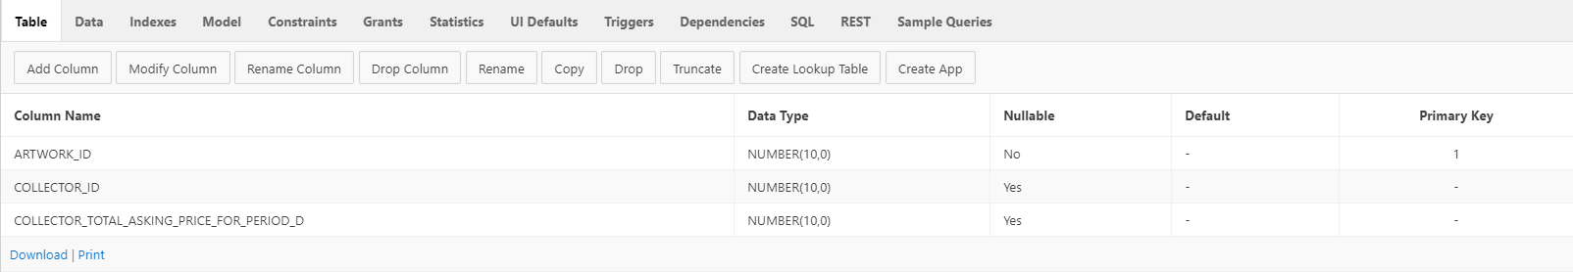

COLLECTOR_SALE

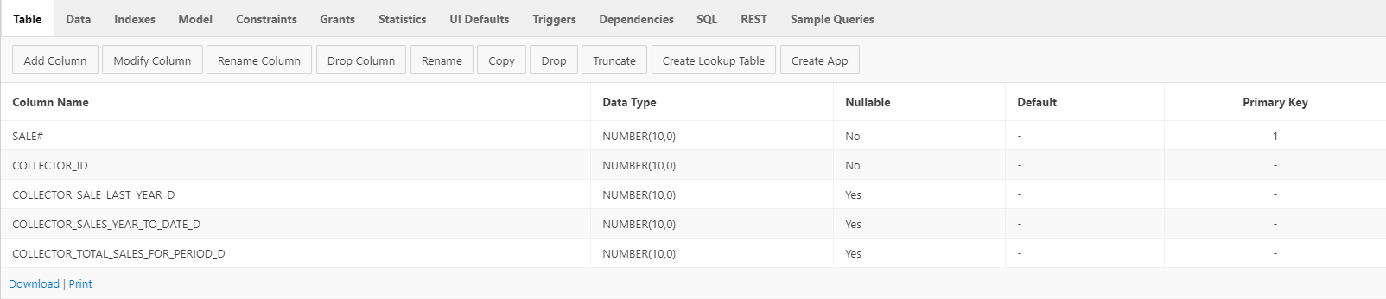

SALE

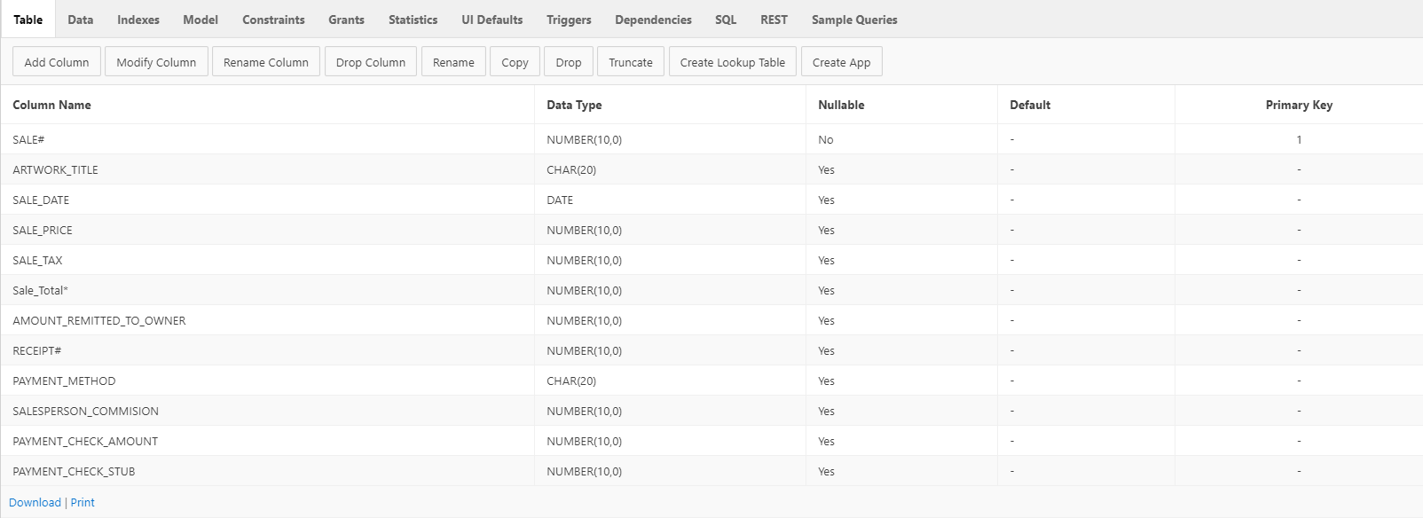

SALE2

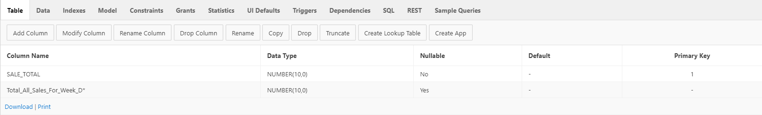

SALEPERSON

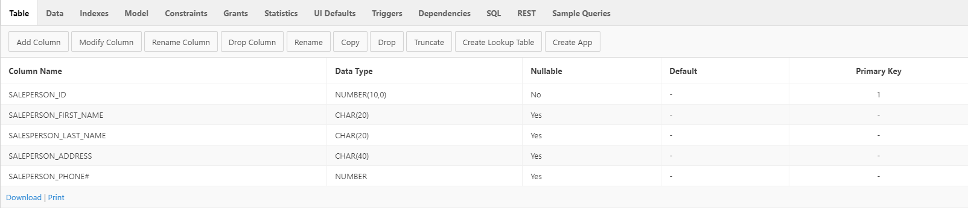

SALE_SALEPERSON

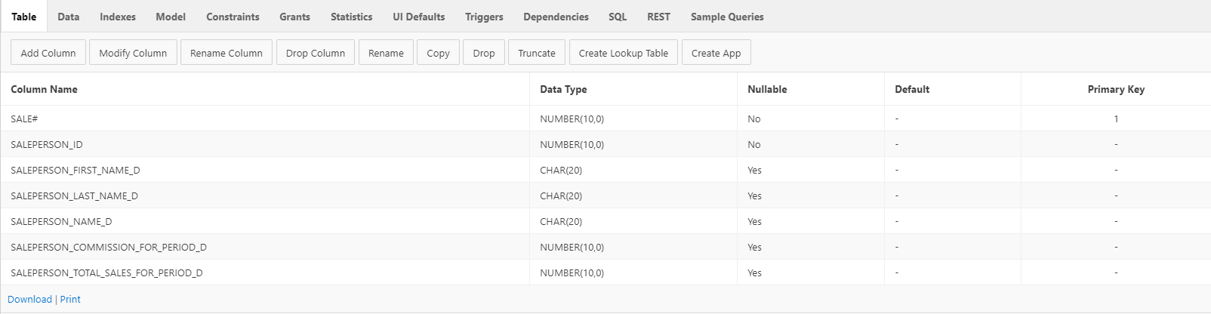

**Screenshot of database in APEX (successfully generated)**

